**Kickstarter Analysis**

**Summary of Conclusions**

1. More campaigns succeed than fail, 53% - 37%
2. May is the most successful month, while December is the least.
3. The top 3 types of campaigns are Theater, Music, and Technology.
4. The most successful campaign is Theater.
   1. Plays are by far the most common type of Theater with a 66% success rate, that might be because they were more reasonable goals in the first place. The max for that was $200,000 and the average of $5,763

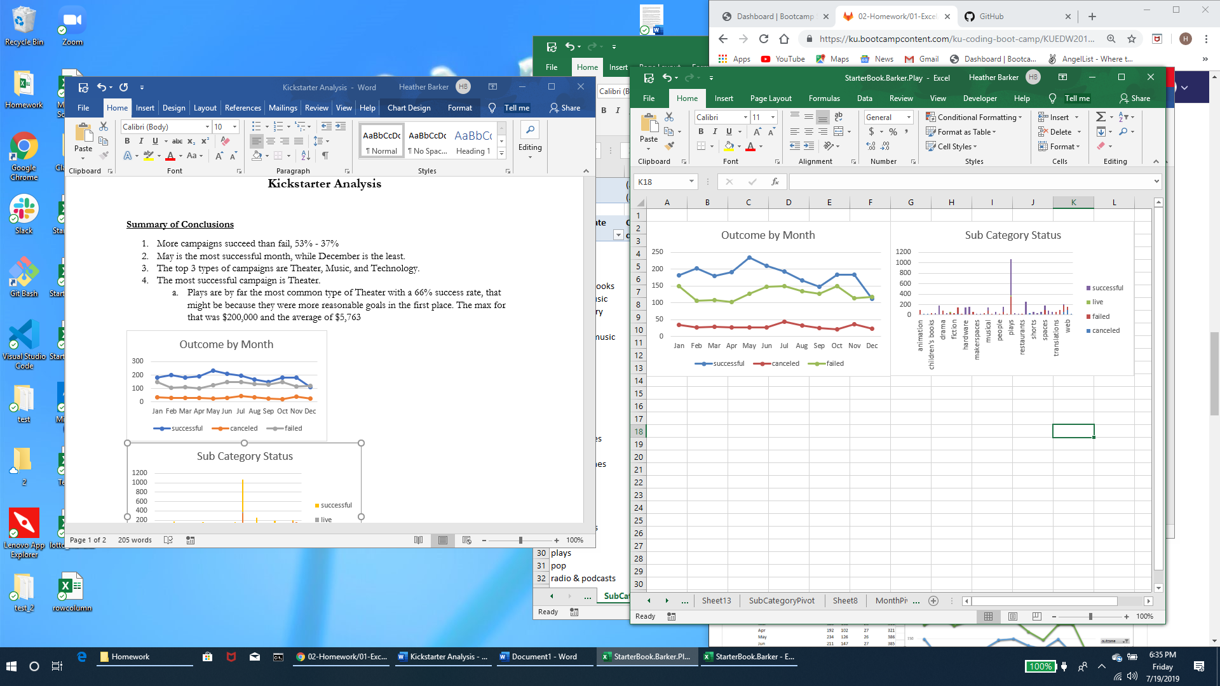

**Limitations**

1. Overall count on backers, the average donations most likely is skewed.
   1. For example - If 100 people donated and 99 gave $10 but one gave $10,000
2. Backers, where were they from? Country of origin?

**Graphs/Tables**

1. What countries were most successful?
2. In what areas?
3. Do different countries have different trends?
4. Based on the goal which were more successful?
5. Correlation between goal – success?

This data spans 8 years of data, starting in May of 2009 and ending in March of 2017. I thought it was incredibly interesting that all the journalism campaigns were cancelled and within 60 days of being created. Can campaigns only go for 90 days? Is there a limit?